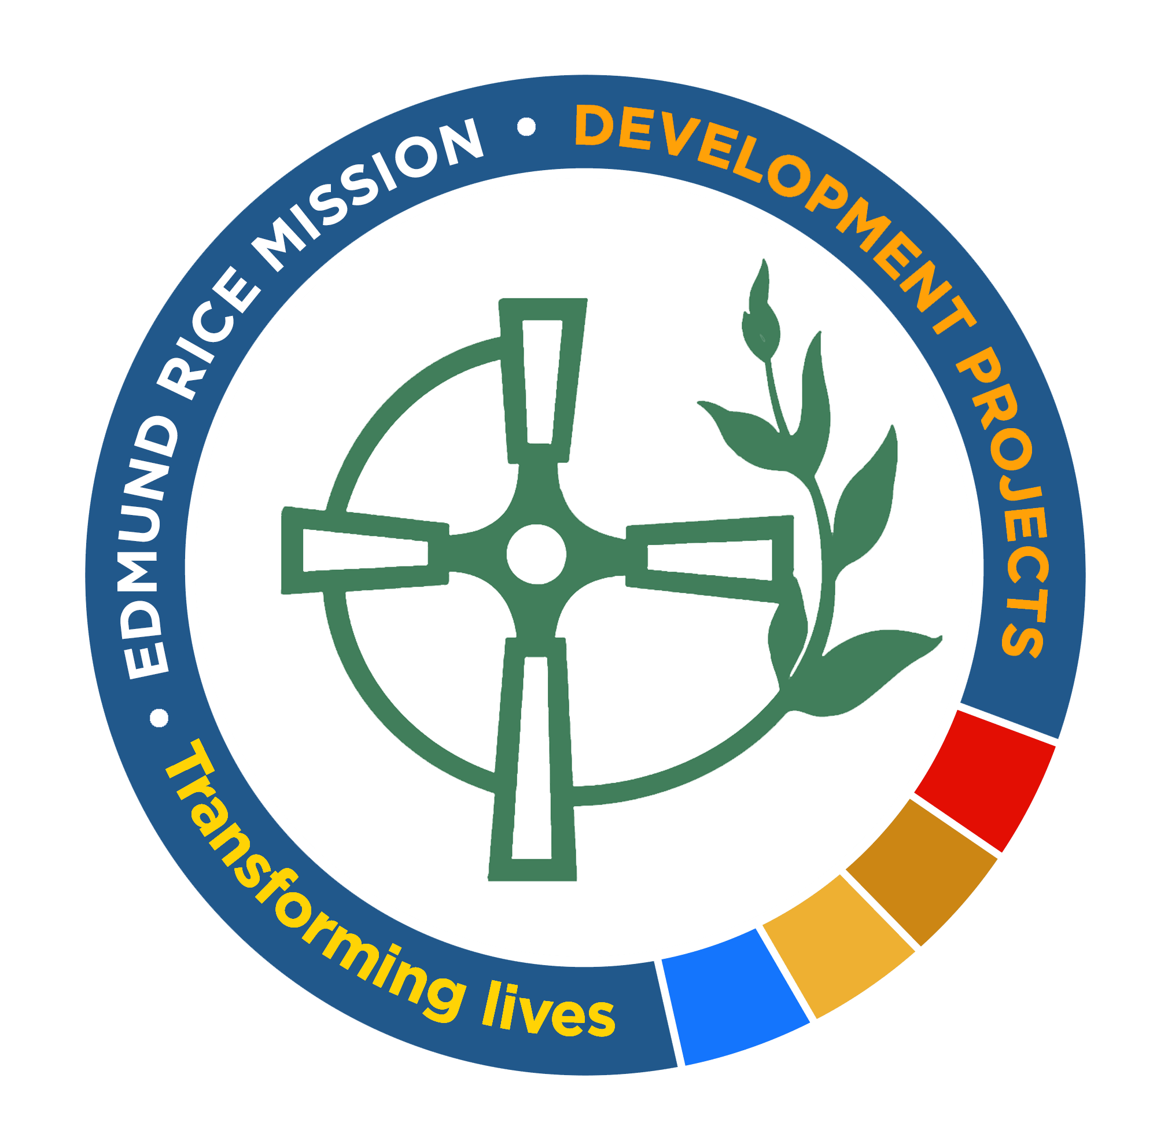

Vulnerable Adult and Child Safeguarding Reporting Form
This form is to be used to formally report all vulnerable adult and child safeguarding incidents relating to any adults and/or children associated with ERFA/ERD funded projects and/or any staff or representatives of ERFA/ERD.
Safeguarding issues associated with the project are defined as follows: issues that occurred within the physical location of the project, during any project activities (onsite or offsite), and/or any issues with project staff both during/after work hours. This does not include external protection issues that occur outside of the project. For example, a project beneficiary attending a health clinic (the funded project) to seek help for a sexual abuse carried out by a family member in her home.
Section 1 of this form must be submitted within 24 hours of an allegation being made.
Section 2 must be filled out on a weekly basis or as additional information becomes available.
Section 3 must be submitted when the investigation has been completed.
If the incident refers to an ERFA funded project please submit this form to CEO@erf.org.au
If the incident refers to an ERD funded project please submit this form to the ERD Safeguarding Officer at naidi@edmundricedevelopment.org.
A copy of this report must be submitted to your Mission Co-ordinator and Governing Body Leader.
Please do not include the names of any individual, except the name of the person(s) who dealt with/are dealing with the vulnerable adult and/or child safeguarding issue.

Project Title: | Donor Code: |  | Date Reported to Donor:
Contact Details:
Please provide contact details for the person who we will liaise with in relation to this safeguarding issue.
Name: |  | Job Title:
Phone Number: |  | Email:
Skype:

Section One – Initial Report
This section must be submitted within 24 hours of an allegation being made
Date/Time incident occurred:
Date the incident was reported:
Who was it reported to:
Name of the Person(s) who dealt with the incident (e.g. Safeguarding Officer):
Who disclosed the incident? (the alleged victim, a relation, a witness?)
Short summary of the incident including the location:
Did the incident occur during project work hours or did it occur outside project hours?
Summary of how the incident has been dealt with to date:
Planned follow up Actions:

Section Two – Detailed Description of Incident and Investigation
This section must be filled out/updated on a weekly basis or as additional information becomes available
Description of alleged victim(s): (for confidentiality reasons please do not include names) |  | D.O.B. or estimated age of person(s) affected:
What is the relationship of the alleged victim(s) to the project? (are they a beneficiary, staff member etc.)
Has he/she been offered support and counselling to ensure their safety and well being? If yes, please describe?
Other persons involved and how they are involved? (for confidentiality reasons please do not include names) | Description: | Involvement:
 | Description: | Involvement:
Description of the person(s) who the allegations has been made against (staff member, project beneficiary etc.)
Is this person still working for the project? Please provide detail:
Is this the first allegation made against this person? If no, please provide detail on previous allegations:
Description of Incident. (Provide as much detail as possible of what has occurred and how it has been dealt with, attach additional pages as required)
Provide a detailed overview of what steps have been taken to investigate this incident to date. (who was interviewed, when were interviews held, by whom, were the relevant authorities informed etc.)
Has this incident been reported to the relevant authorities (police, social workers etc. ) where necessary:
If yes, who?
Name of Authority: Date
What is the status of this case with this authority:

What is the current status of this case within your project?
Date of last update:

Section Three – Lesson Learnt
This section must be submitted when the investigation has been completed

Key Learnings: | Please detail the key learnings that have occurred as a result of this incident. How has your safeguarding system been strengthened? How will the project prevent this incident from occuring again? What further training will be carried out, will the safeguarding policy be updated, if so, how?
Name and Signature of Governing Body Safeguarding Officer |  | Date:
Name and Signature of Project Manager |  | Date:
Name and Signature of District Leader |  | Date:
For Office Use: Ensure this is logged in ERFA ICC Register or ERD Vulnerable Adult & Child Safeguarding Report Register
Date received: | ERFA ICC/ERD Vulnerable Adult & Child Safeguarding Report Reference number:
Description of actions taken:

Details of outcome:

Report deemed closed when signed. Name of authorised ERFA/ERD person:

Signature: Position: Date:

